CENTRAL UNIVERSITY OF RAJASTHAN
Department of Culture and Media Studies
(Departmental Activities 2019-20)

13th – 15th March, 2020: Workshop on Artificial Intelligence and Cultural Heritage of India.
The Department organised a three day DST sponsored national workshop on the “Application of Artificial Intelligence for conservation of Cultural Heritage of India”.
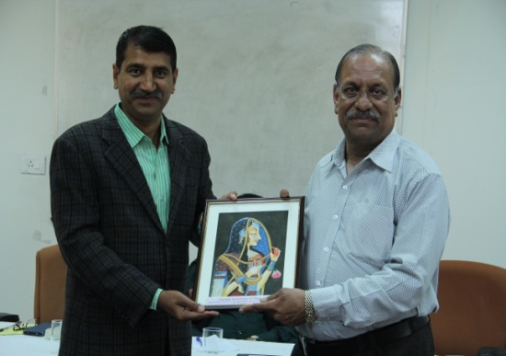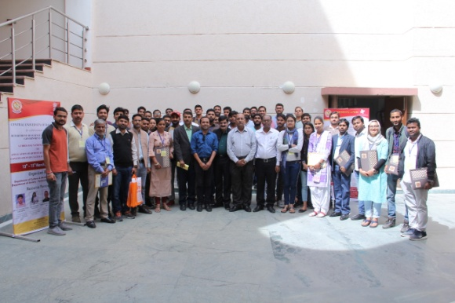
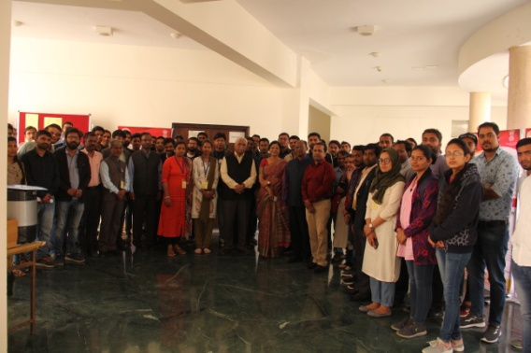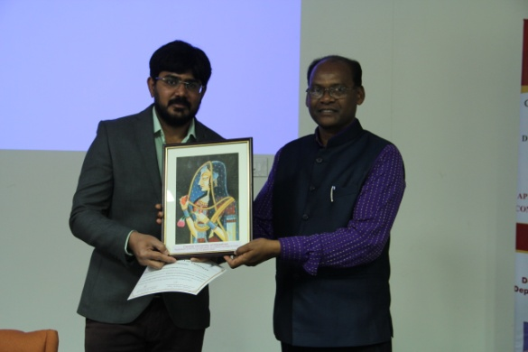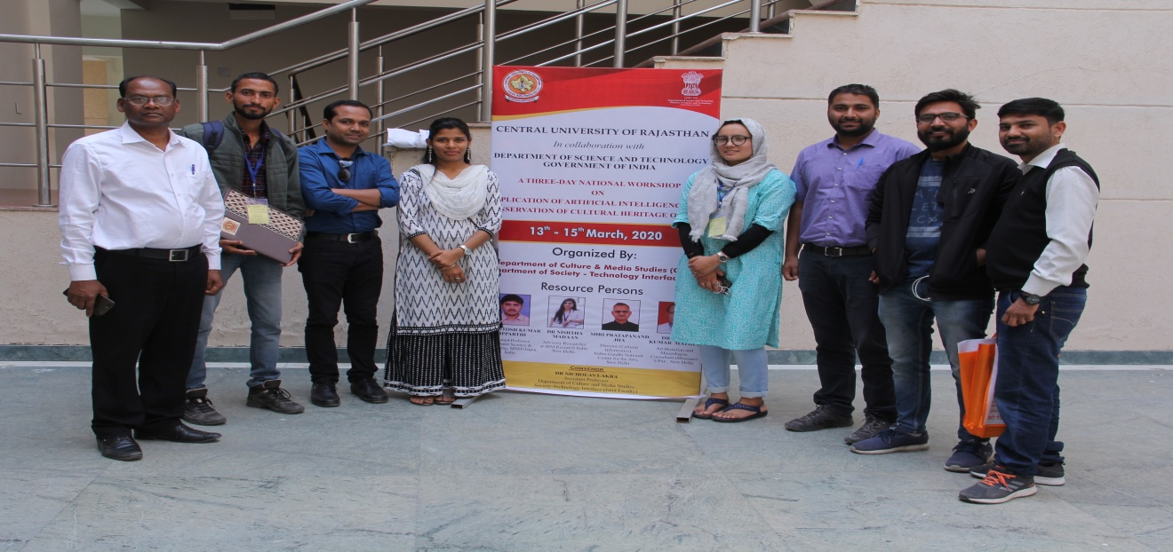
It attracted participants from all over the country who were engaged for 3 days with eminent resource persons like Dr. Santosh Vipparthy, MNIT (Jaipur), Dr. V.K.Mathur, Art Historian & Museologist (New Delhi) and Dr. Nisthaa Madan, IBM (New Delhi). Dr. Nicholas Lakra, Asst. Professor, CMS Dept was the convenor of the workshop. The workshop was held in collaboration with Department of Society-Technology Interface, Central University of Rajasthan.
29th January, 2020: Indian Newspaper Day
Students of the Department (M.A., PG Diploma & Ph.D) organised a series of events to celebrate the Indian Newspaper Day. It included an exhibition of earlier editions of Indian newspapers and presentation of news stories from different newspapers on socially relevant and contemporary issues.
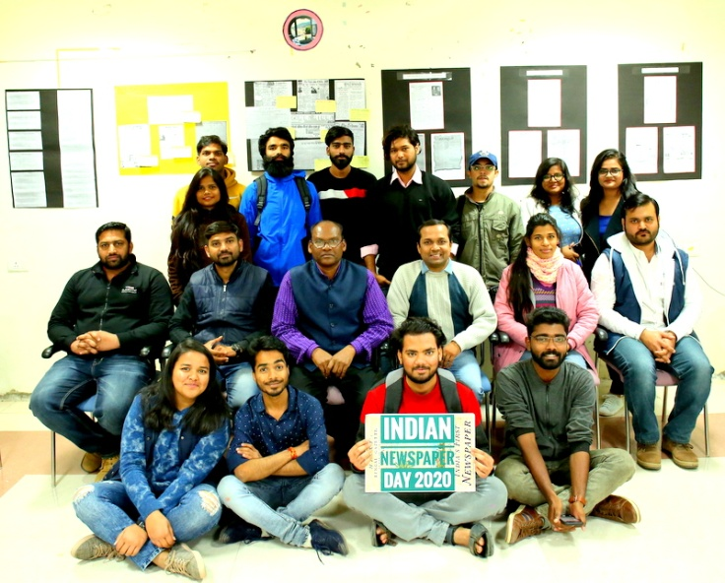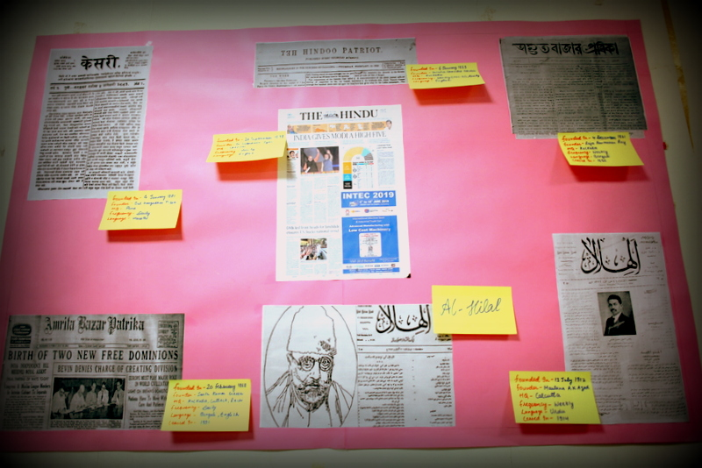

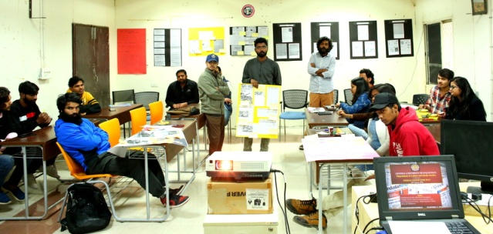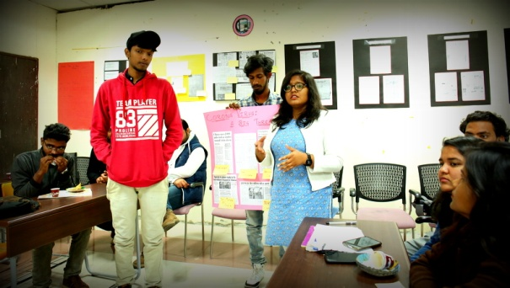

The programme ended with screening of PSBT documentary – Brokering News- Media, Money & Middlemen followed by discussion on it.

18th November, 2019: Media Industry Tour
In order to give first-hand exposure to the working of media production house, both audio-visual and print, the Department organised a media industry tour for its students to Doordarshan Kendra, Jaipur and Dainik Bhaskar Newspaper, Jaipur.
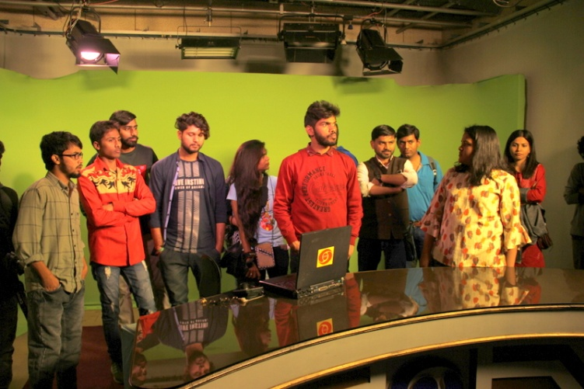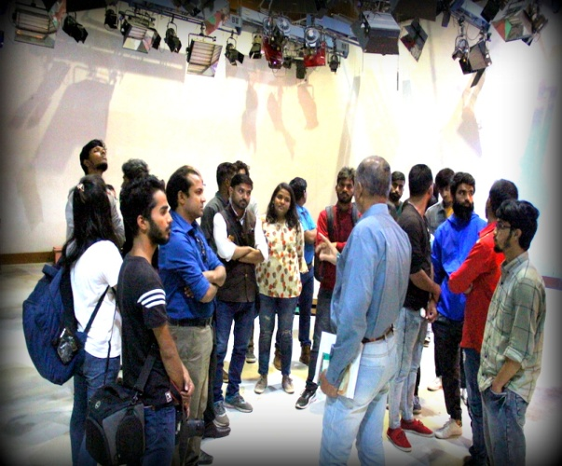

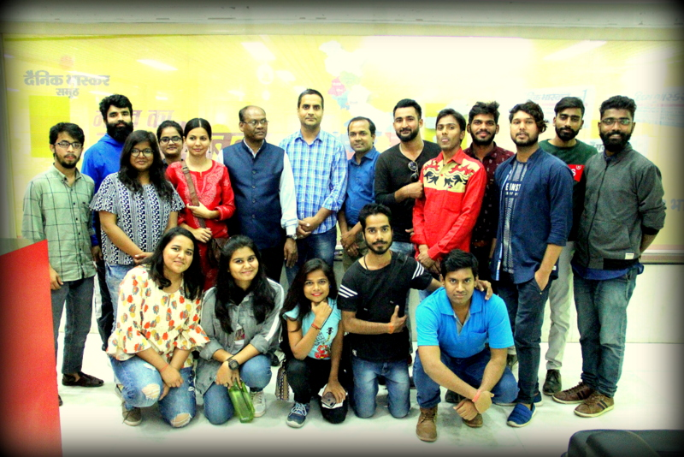

Students were introduced to the concepts of live recording, television studio set up, editing – both audio-visual and print, responsibilities of editors and reporters.
1st – 10th November, 2019: Workshop on Video Production
Mr. Rochak Sahu, Independent Filmmaker, Mumbai conducted a ten days workshop on Video Production and Production of Fiction Film.
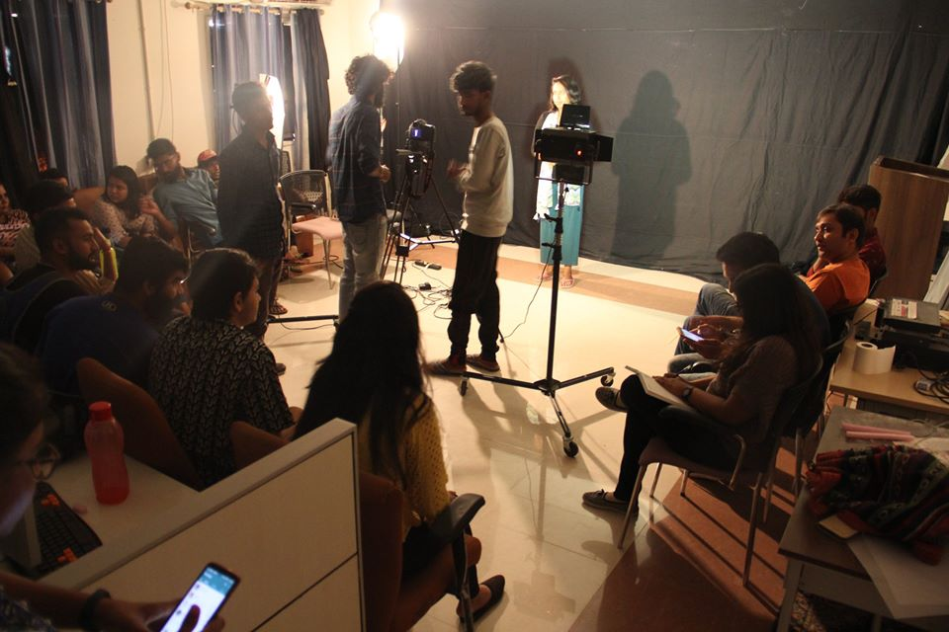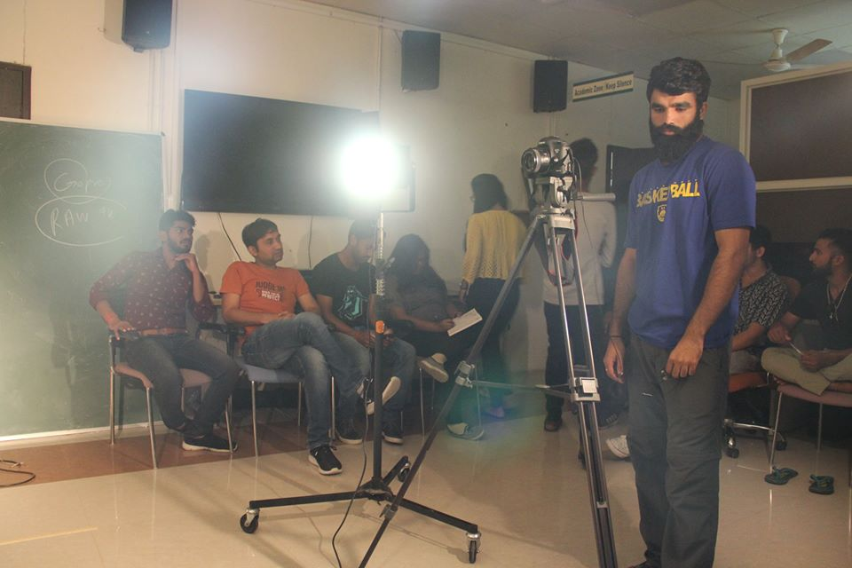

26th – 30th August, 2019: Lecture-cum-Workshop on Video Production
Mr. Ramesh Chandra, IIMC, New Delhi conducted a five days lecture-cum-workshop on basics of video production for M.A. (1st Sem) & PG Diploma students.
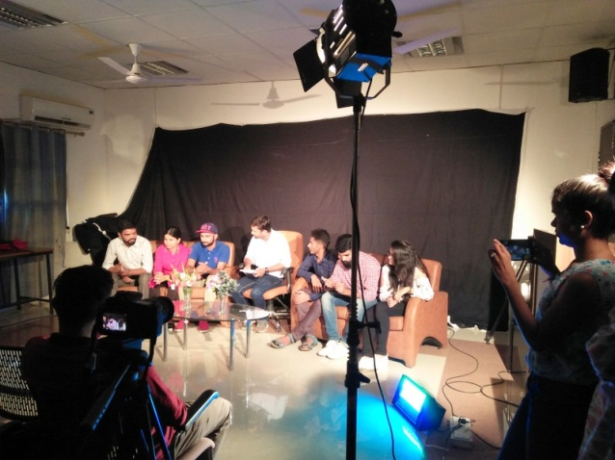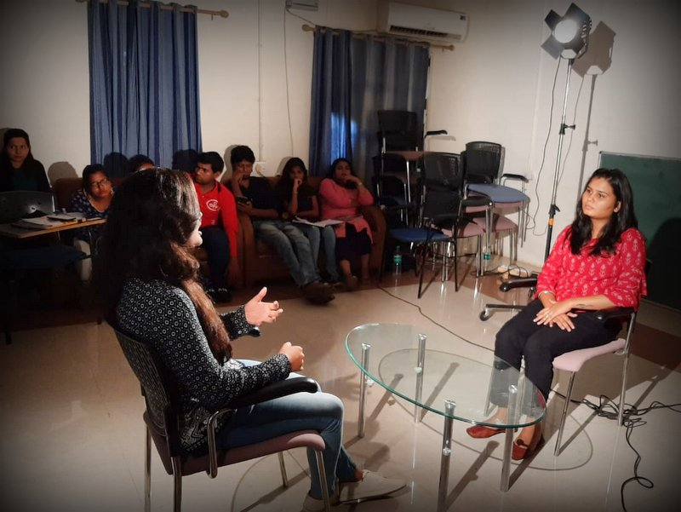
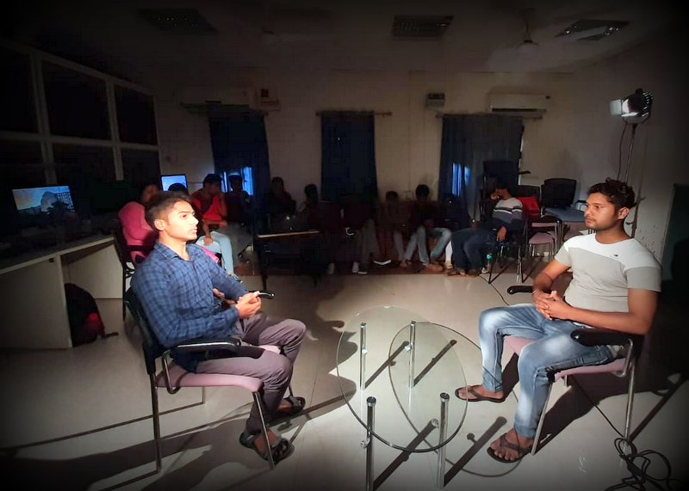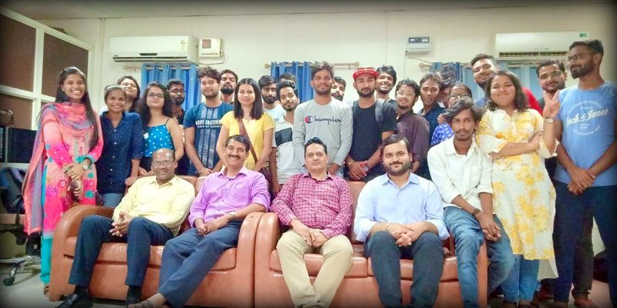

19th August, 2019: World Photography Day
The Department celebrates every year the World Photography Day by organising photography competition for students of the University as well as other universities through online. The theme for 2019 photography competition was – ‘Still Life’. Students organised caption writing competition and an event of photo story.
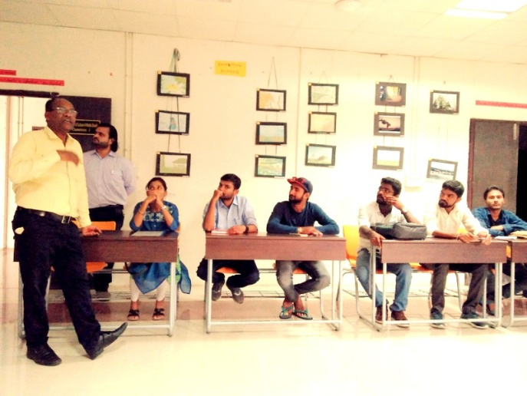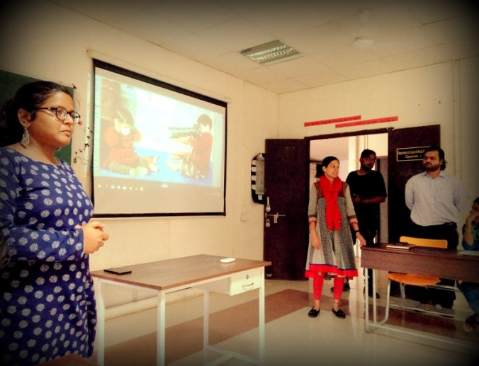
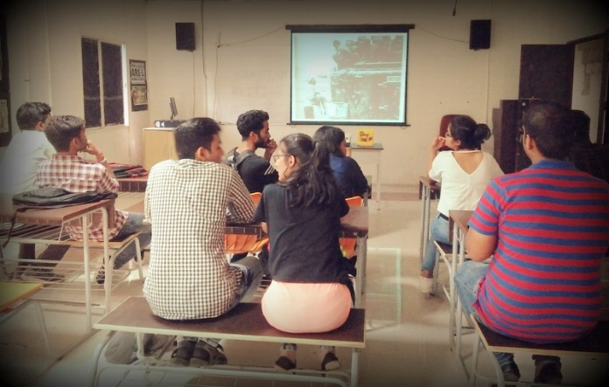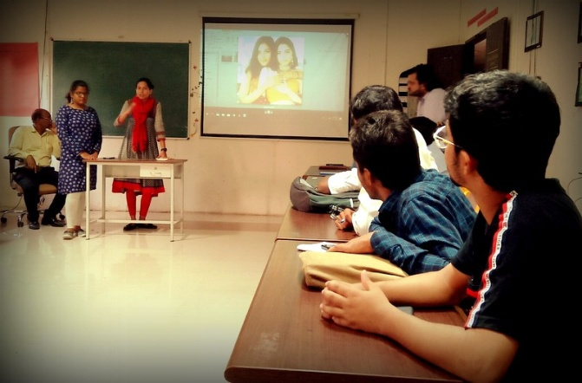
29th July, 2019: Special Lecture by Prof. Mrinal Chatterjee
Prof. Mrinal Chatterjee, IIMC (Dhenkanal,Odisha) gave a special lecture on the topic – “Future of Mass Media in India”.
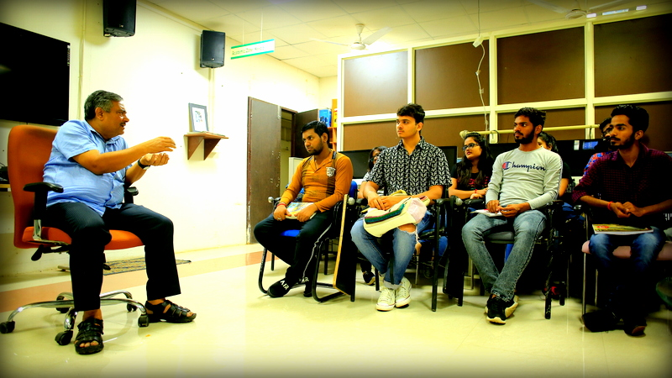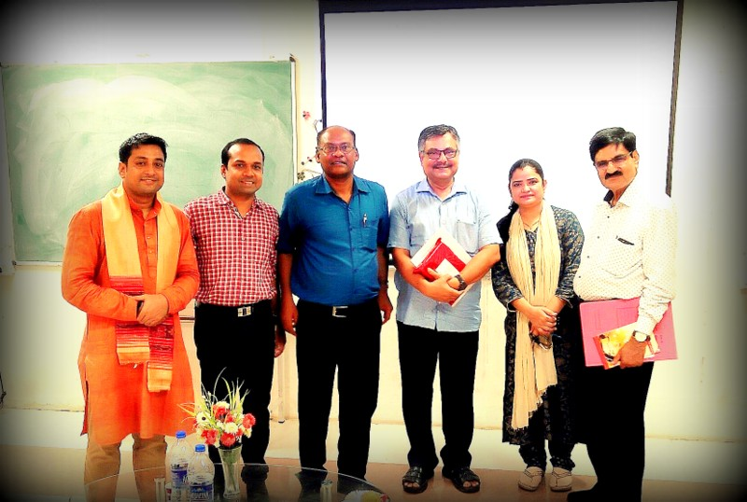
19th July, 2019: Induction Programme for Freshers
The newly admitted students (2019 batch), both M.A. & PG Diploma were oriented to the Programme, Course Structure, Media Lab by the faculty members, M.A. (III Sem) students and research scholars of the Department.
