Photo | Designation | Name | Period
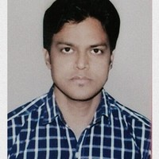 | Library Attendant | Mr. Vinod Sharma | 2012-2017
Previous Library Staffs

